**User Manual**

Prepared By:

|  |  |  |  |
| --- | --- | --- | --- |
| **Member** | **ID#** | **Program** | **Signature** |
| Coral S. Schmidt Montilla | #148830 | Computer Science |  |
| Jaime J. Cuebas Ruiz | #121703 | Computer  Engineering |  |
| Christopher Ortiz | #130607 | Computer Science |  |
| Christian Brito | #9734 | Computer Science |  |
| Taishali N. Jimenez Quinones | #148017 | Computer Engineering |  |

**Table of Contents**

**Application Overview** 3

**🔑Key Features** 3

**Getting Started** 3

**🖥️ System Requirements** 3

**🧑‍💻 How to Register** **Error! Bookmark not defined.**

**🧭Main Screens** 4

**📝Sign Up Page** 4

**🔐Log In Page** 5

**🏠 New Client Home Page** 5

**🔁 Returning Client Home Page** 6

**🛠️ Resume Builder Page** 7

**🎒 Step 1: Personal & Educational Information For High School Students** 7

🎒 **Step 2: Work Experience For High School Students** 8

**🎓 Step 1: Personal & Educational Information For College Students** 9

**🎓 Step 2: Work Experience For College Students** 10

**🧑‍🔧 Step 1: Personal & Educational Information For Out of School** 13

**🧑‍🔧 Step 2: Work Experience For Out of School** 14

**🧾 Step 3: Select Resume Template** 19

**🔒 Administration Page (For Authorized Users Only)** 20

**🔧 Troubleshooting** 20

# **Application Overview**

Resume Builder is an easy-to-use web application that helps you create a polished, professional resume in the blink of an eye. Whether you’re a student, a job seeker, or a professional, this app simplifies the process step-by-step.

# **🔑Key Features**

🎯 Select your job type and education level

📝 Fill out guided resume sections (with helpful tips!)

🎨 Choose a template tailored to your field

📥 Download your resume as a clean, professional PDF

📚 Learn what to include in each section, as you go

# **Getting Started**

## **🖥️ System Requirements**

🌐 Works on any modern browser (Chrome, Safari, Firefox, Edge)

📶 Internet connection required

🖥 Optimized for desktop, tablet, and mobile

# **🧭Main Screens**

**📝Sign Up Page**

Figure : Sing up page

Create your Resume Builder account to get started.

📌 **Fields:**

* **Email:** Use a valid and accessible email address
* **First Name**
* **Middle Name (optional)**
* **Last Name:**
* **Password:** Must be at least 8 characters long
* **Confirm Password:** Re-type your password to avoid mistakes

🛡️ Password Tip (2025 Standards):

Use a passphrase that’s easy to remember but hard to guess—ideally 12+ characters mixing uppercase, lowercase, numbers, and symbols.

💡 Avoid patterns like “Password123!” or personal info.

✅ Example: Blue!Tiger*Rodeo88

Once all fields are filled in, click **Sign Up** to proceed to your personal dashboard.

**🔐Log In Page**

Figure : Log in page

Returning users can sign in to access their resume dashboard and previously saved resumes.

📌 **Fields:**

* **Username:** The name used during registration
* **Password:** Your secure password

Other options:

✅ Remember Me: Keeps you signed in on the current device

🔁 Forgot Password?: Use this link to reset your credentials if needed

🆕 Don’t have an account? Click Sign Up to create one

🛡️ **Login Tip:**  
Always log in from a secure network. Avoid using public Wi-Fi to keep your credentials safe from interception.

## **🏠 New Client Home Page**

After successfully signing up, new users are greeted with a streamlined dashboard designed to help them start building their resume right away.

📌 **What You’ll See:**

👋 A Welcome Message encouraging you to get started

👉 A large "Create Your Resume" button that launches the step-by-step resume builder process

🔍 A clean, minimal layout with user-friendly navigation

Figure : New client home page

## **🔁 Returning Client Home Page**

Returning users will see a personalized dashboard showing their progress and saved resumes.

**📌 What You’ll See:**

📂 A list of previously created or saved resumes

✏️ Options to **Edit**, **Download**, or **Delete** resumes

➕ A button to **Create a New Resume**

🕓 Timestamps showing the last time each resume was modified

Figure 4: Returning client home page

💡 Tip: Use the edit option to keep your resume current for each new opportunity.

**🛠️ Resume Builder Page**

This is where users create their resume in a guided, three-step process. Each step helps gather personal, educational, and professional information before selecting a resume style and downloading it.

Figure : Personal & educational information: Chose your education level

### **🎒 Step 1: Personal & Educational Information For High School Students**

📌 **You’ll fill in:**

👤 **Personal Info:**

* Full Name (First, Middle, Last)
* Email Address
* Date of Birth (optional)
* Physical Address
* LinkedIn Profile (optional)

**🎓 Education Info:**

* School/Institution Name
* Degree & Field of Study
* Start and End Dates
* Year (e.g., Sophomore, Senior)
* GPA (optional)
* Honors & School
* Location

💡 **Pro Tip:** Add your LinkedIn only if it's updated and matches your resume. Keep formatting clean and dates accurate.

Figure : Personal & educational information: Student

### A screenshot of a computer AI-generated content may be incorrect.🎒 **Step 2: Work Experience For High School Students**

📌 **You’ll fill in**

💼 **Job Info:**

* Job Title (e.g., Babysitter, Cashier, Camp Assistant)
* Company or Organization Name
* Location (City, State)
* Start and End Dates (Month/Year)
* Responsibilities / Duties (short bullet points)
* Type (Part-Time, Internship, Volunteer)

Figure : Experience & skills: Student

💡 **Pro Tip:** It’s okay if it’s not a “real job.” Volunteering, tutoring, or family work still count!

### **A screenshot of a computer AI-generated content may be incorrect.🎓 Step 1: Personal & Educational Information For College Students**

📌 **You’ll fill in:**

🧑‍🎓 **Personal Info:**

* Full Name (First, Middle, Last)
* Email Address
* Date of Birth (optional)
* Physical Address
* LinkedIn Profile (optional)

🎓 **Education Info:**

* College/University Name
* Degree & Field of Study
* Start and Expected Graduation Date
* Current Year (e.g., Sophomore, Senior)

Figure : Personal & educational information: College

* GPA (optional)
* Clubs / Organizations
* School Location

💡 **Pro Tip:** List any notable coursework, awards, or organizations that help show your strengths and interests. Keep it clean and relevant.

### **🎓 Step 2: Work Experience For College Students**

🧭 Department Selection:

Choose the department that best aligns with your major or interest:

* Business
* Science
* Engineering
* Humanities

Figure : Chose your department: College

📌 You’ll fill in:

💼 Job Info:

* Job Title (e.g., Intern, Research Assistant, Cashier)
* Company or Organization Name
* Location (City, State)
* Start and End Dates (Month/Year)
* Responsibilities / Duties (short bullet points)
* Type (Part-Time, Internship, Volunteer)

💡 Pro Tip: Show how your experience ties into your academic goals. Even non-professional roles (like volunteer work) count and tell your story.

Figure : Chose your department: College: Business

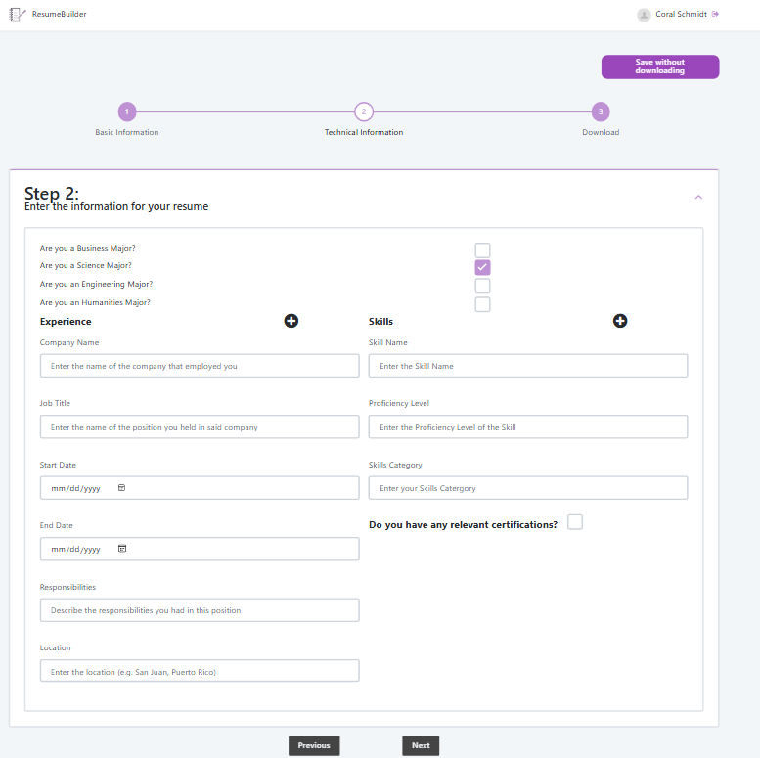

💼 Portfolio Requirement:

Depending on the department you select, an optional Portfolio Upload section may appear.

📁 Business students do not need to submit a portfolio.

🛠️ Engineering and Science students will be prompted to upload relevant files such as projects or designs.

🎨 Humanities students may be asked to upload writing samples or creative work.

Figure : Chose your department: College: Science

💡 Pro Tip: If you’re asked to upload a portfolio, choose work that supports your future job goals—capstone projects, lab reports, writing samples, or designs.

Figure : Chose your department: College: Engineering

Figure : Chose your department: College: Humanities

### **🧑‍🔧 Step 1: Personal & Educational Information For Out of School**

📌 You’ll fill in:

🧑‍💼 **Personal Info**:

* Full Name (First, Middle, Last)
* Email Address
* Date of Birth *(optional)*
* Physical Address
* LinkedIn Profile *(optional)*

🎓 **Education Info**:

* Most Recent School or Institution
* Highest Level of Education Completed *(e.g., High School Diploma, Bachelor’s Degree)*
* Field of Study
* Graduation Date or Last Year Attended
* Certifications or Licenses *(if any)*

Figure : Personal & educational information: Out of school

* School Location

💡 **Pro Tip**: If it’s been a while since you were in school, highlight any ongoing learning—online courses, certifications, or self-study count!

### **🧑‍🔧 Step 2: Work Experience For Out of School**

🧭 **Department Selection**:  
Choose the department that reflects your field or area of interest:

* Business
* Science
* Engineering
* Humanities

**📌 You’ll fill in:**

💼 **Job Info**:

Figure : Chose your department: Out of school

* Job Title *(e.g., Technician, Customer Service Rep, Freelancer)*
* Company or Organization Name
* Location (City, State)
* Start and End Dates *(Month/Year)*
* Responsibilities / Duties *(short bullet points)*
* Type *(Full-Time, Part-Time, Freelance, Volunteer)*

📁 **Portfolio Requirement**:  
Depending on your department selection in Step 1, a **Portfolio Upload** option may appear.

📁 *Business users* are not required to upload a portfolio.

🛠️ *Engineering or Science professionals* can showcase past work, such as technical reports or project documentation.

🎨 *Humanities users* may upload writing samples or other creative content.

💡 **Pro Tip**: Use this section to demonstrate your most relevant and recent experience. Focus on accomplishments and measurable impact.

Figure : Chose your department: Out of school: Business



Figure : Chose your department: Out of school: Science

Figure : Chose your department: Out of school: Engineering

Figure : Chose your department: Out of school: Humanities

### **🧾 Step 3: Select Resume Template**

Now that you’ve entered all your information, it’s time to choose how your resume will look.

📌 **Available Templates:**

**📄Default –** Simple, straight to the point, good for starting out.

🧱 **Color Block Resume** – Modern, bold, best for tech roles.

🏨 **Modern Hospitality Resume** – Balanced layout, great for service jobs.

📘 **Stylish Teaching Resume** – Clear and readable, ideal for education.

Figure 20: Select resume template

✅ Click **Preview** to see the template in action  
✅ Click **Download** to save your resume as a **PDF**

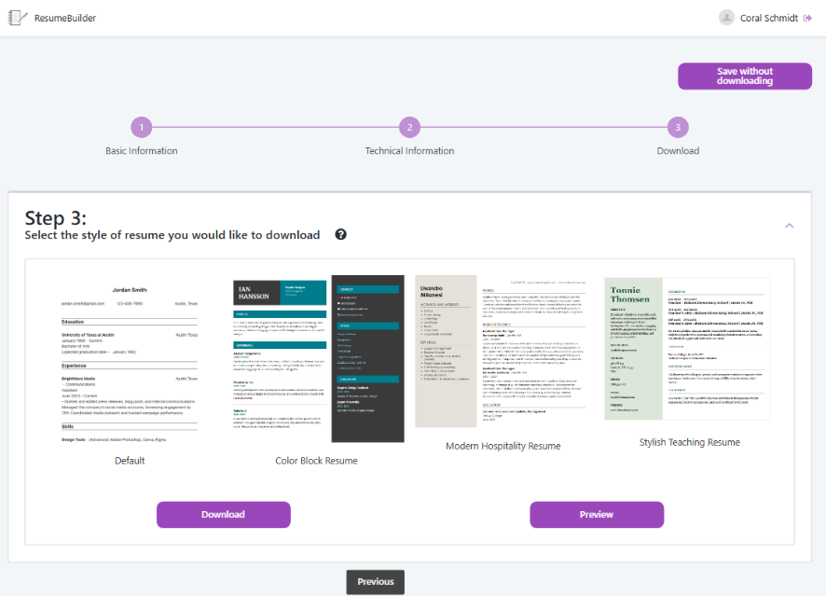💡 **Design Tip:** Choose a style that fits your industry. For formal roles (law, academia), go simple. For creative or tech roles, bold is okay!

## **🔒 Administration Page (For Authorized Users Only)**

The **Administration Dashboard** is accessible only to the project creators and system admins. It offers real-time insights into resume creation activity and system usage for quality control and performance tracking.

📌 **Key Features Shown:**

📈 **Resumes Started:** Number of users who began the resume process

❌ **Resumes Cancelled:** Number of users who exited before finishing

✅ **Resumes Finished:** Completed and downloaded resumes

🧾 **Last Submitted Resumes:** Includes user ID, name, file type, and creation date

# **🔧 Troubleshooting**

|  |  |  |
| --- | --- | --- |
| ❌ Issue | 🛠️ How to Fix It | 💡 Tip |
| **Resume won’t download** | - Make sure all required fields are filled  - Confirm your internet is connected  - Try refreshing or switching browsers | Use Chrome or Firefox for best results. Avoid public Wi-Fi when downloading files. |
| **Resume didn’t save** | - Ensure you're logged in - Click **“Save”** after making edits - Don’t close the browser mid-session | Use the **“Save without downloading”** button to keep your progress in the cloud. |
| **Missing job suggestions** | - The job suggestion API might be temporarily offline - General resume tips will appear instead | Resume tips are always shown. Refresh later to access job-specific content. |
| **Fields not accepting input** | - Check for missing or invalid characters - Refresh and try again if the form freezes | Avoid special characters in fields like name, job title, or degree. |
| **App not loading correctly** | - Clear browser cache and cookies - Restart your browser or use a different one | Make sure your browser is updated to the latest version for smooth performance. |

Table : Troubleshouting Ideas